Data View to Public Health

# Data Collected

## User Profile

* Personal identification <email, social network accounts>
* Location
* Age
* Gender

## COVID-19 Screening

* Travel history
* Contact history
* Test history
* [open question] should we ask some questions around the health condition, i.e. diabetes, high blood pressure, pregnancy? CDC bot did ask some of those question

## Symptoms

|  |  |
| --- | --- |
| Symptom | Data Value |
| General Feeling | Scale 1-10 |
| Fever | Yes <highest temperature>  No |
| New or worsening cough | Scale 1-10 |
| Muscle or body aches | Scale 1-10 |
| Shortness of breath | Option 1: Scale 1-10  Option 2:  Yes <spO2>  No |
| Sore throat or itchy/scratchy throat | Scale 1-10 |
| Feeling more tired than usual | Scale 1-10 |
| Chills or shivering | Yes  No |
| Runny/stuffy nose or sneezing | Yes  No |
| Nausea or Vomiting | Yes  No |
| Abdominal pain | Scale 1-10 |
| Diarrhea | Yes <how many times>  No |
| Lost sense of smell and taste | Yes  No |
| Other symptoms | Free text |

# What Views might be interesting for them

## Better understand the Clinical Presentation and Course

*[https://www.cdc.gov/coronavirus/2019-ncov/hcp/clinical-guidance-management-patients.html#clinical-presentation](https://www.cdc.gov/coronavirus/2019-ncov/hcp/clinical-guidance-management-patients.html" \l "clinical-presentation)*

*“Among reports that describe the clinical presentation of patients with confirmed COVID-19, most are limited to hospitalized patients with pneumonia.”*

**“***Risk factors for severe illness are not yet clear, although older patients and those with chronic medical conditions may be at higher risk for severe illness.”*

*“The fever course among patients with COVID-19 is not fully understood; it may be prolonged and intermittent.”*

*“Clinical presentation among reported cases of COVID-19 varies in severity from asymptomatic infection to mild illness to severe or fatal illness. Some reports suggest the potential for clinical deterioration during the second week of illness. In one report, among patients with confirmed COVID-19 and pneumonia, just over half of patients developed dyspnea a median of 8 days after illness onset (range: 5–13 days). In another report, the mean time from illness onset to hospital admission with pneumonia was 9 days.”*

**Top Clinical Characteristics** <[example](https://www.nejm.org/doi/full/10.1056/NEJMoa2002032)>

Incubation period: i.e. 4.0 (2.0-7.0)

Reported Symptom:

* Fever:
* fever was present in 44% at hospital admission, median temperature 37.3 (36.7 – 38.0)
* and developed in 89% during hospitalization, median temperature 38.3 (37.8 – 38.9 )
* Cough – 67.8%
* Fatigue – 38.1%
* Sputum Production – 33.7%
* Shortness of breath – 18.7%
* Myalgia – 14.9%
* Sore throat – 13.9%
* Headache – 13.6%
* …

Risk Factors:

Among more than 44,000 confirmed cases of COVID-19 in China as of Feb 11, 2020, most occurred among patients aged 30–69 years (77.8%), and approximately 19% were severely or critically ill. Case-fatality proportion among cases aged ≥60 years was: 60-69 years: 3.6%; 70-79 years: 8%; ≥80 years: 14.8%. Patients who reported no underlying medical conditions had an overall case fatality of 0.9%, but case fatality was higher for patients with comorbidities: 10.5% for those with cardiovascular disease, 7% for diabetes, and 6% each for chronic respiratory disease, hypertension, and cancer. Case fatality for patients who developed respiratory failure, septic shock, or multiple organ dysfunction was 49%.

How it progresses:

* Some reports suggest the potential for clinical deterioration during the second week of illness.
* In one report, among patients with confirmed COVID-19 and pneumonia, just over half of patients developed dyspnea a median of 8 days after illness onset (range: 5–13 days).
* In another report, the mean time from illness onset to hospital admission with pneumonia was 9 days.
* In one report, the median time from symptom onset to ARDS was 8 days.[3]

Reference:

<https://www.nejm.org/doi/full/10.1056/NEJMoa2001191>

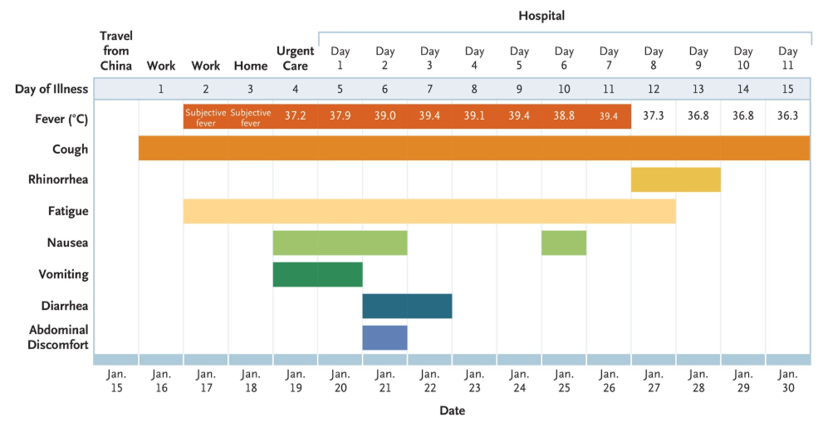

## Identify the similarity of symptom patterns <Syndromic Surveillance>

<https://www.cdc.gov/nssp/index.html>

<https://www.cdc.gov/nssp/news/2020/02-february/news.html#Collaborations>

* Clusters of case with similar symptoms (location based??)
* Case similarity with confirmed cases
* The model could help to decide if more testing and sampling is needed in an area

<if an area have a surging reports with high similarity with confirmed cases, but not enough testing are done there>

## Identify the potential hot spot and take intervention early

* Where have the most existing reports, the similarity of symptoms is high
* Where we see the most increased reports

## Identify the potential audience for blood plasma donation for treatment